Koinonema sp. Buch, Martins & Branco 2017
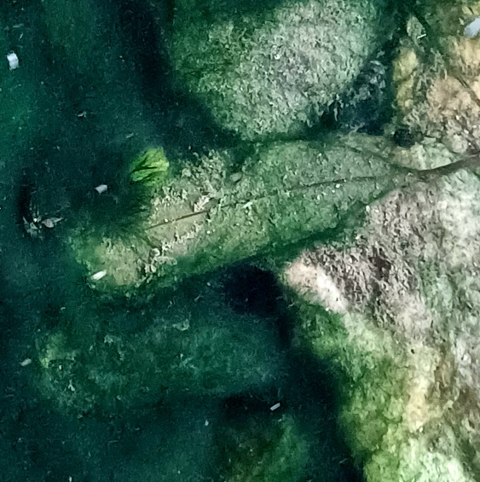

Phylum: Cyanobacteriophyta
Class: Cyanophyceae
Order: Oscillatoriales

Habitat: benthic
Distinctive features: Simple filaments of no special characters forming macroscopic mats on the bottom sediments in shallow water. Later in development clumps detach from the mats and float.
Organization: filamentous
Color: intense blue-green
Cell shape: cylinder
Colony shape: macroscopic mats or floating chunks
Cell diameter (D): 9.2 – 15.2 μm, average: 12.2 μm (N=250).
Cell length (L): 2.9 – 8.6 μm, average: 5.75 μm (N=250).
Cell biovolume: ~700 μm³.
Biovolume equation: Cylinder, V = L π (D/2)².
Filament length: 35 – 410 (3900) μm
Cells per filament: not determined
Colony diameter: several mm to tens of cm

Morphological features:
This filamentous cyanobacterium (Plate 1) forms macroscopic benthic mats covering stones and fine sediments in the shallow waters, of up to ~1 m depth (Plate 2, 3). At a later life stage pieces of the mat float to form floating aggregates (Plate 4). Microscopic examination shows free, straight, isopolar, unbranched filaments with a blue-green coloration and no mucilaginous sheath (Plate 1). Filament lengths ranged from 35 to 410 µm, with a mean length of 170 µm. The terminal cell was rounded, without a calyptra (cap-like structure), and the filaments occasionally exhibited granulation. Cells along the filaments were uniform in appearance, wider than long, with mean dimensions of ~ 12 µm diameter and 5 µm long. No cellular differentiation was observed, a characteristic feature of the order Oscillatoriales. Gliding ability is typical. Based on these characteristics, the cyanobacterium was initially classified as Phormidium sp., but molecular tools confirmed it belonged to the genus Koinonema, and is most likely a new species, to be named Koinonema galileica Kaplan-Levy et al.
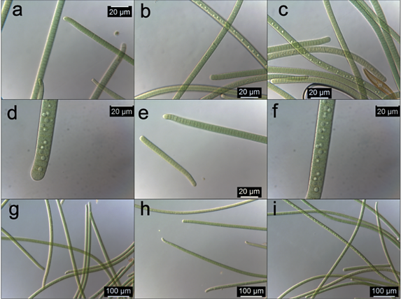
Plate 1. Microscopic images of the Koinonema sp. from Lake Kinneret. (a–i) Images of the microalga taken at different angles and magnifications, showing the simple structure of cells and whole filaments. The higher magnification photos (d, f) show details of endcell, cross walls, and granules. Photos by Alla Alster, 2023.
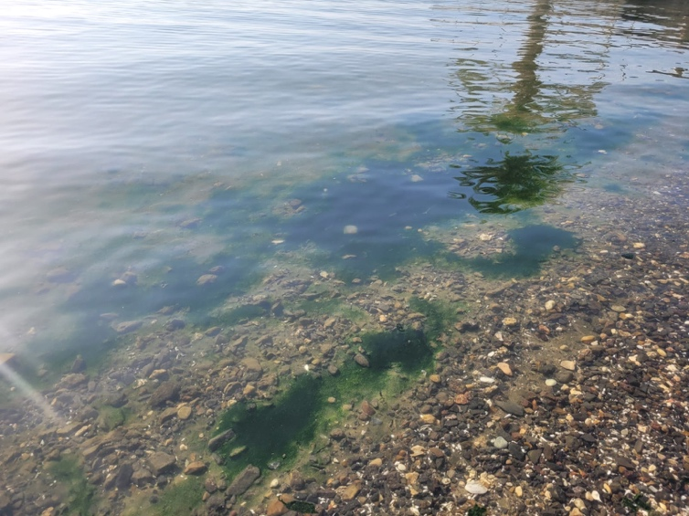
Plate 2. Benthic mat of Koinonema sp. covering the sediments in the shallow waters at Moshavat Kinneret beach, 29 May 2023, the site and time the species was first recorded. Photo by Shiran Unger, Nature and Parks Authority.

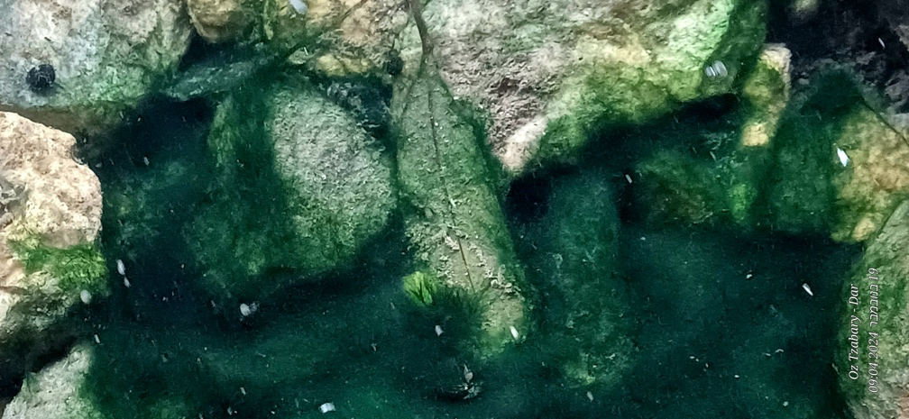
Plate 3. Benthic mat of Koinonema sp. covering rocks opposite the Kinneret Limnological Institute, 19 Nov 2024. Photo by Oz Tzabari-Dar.
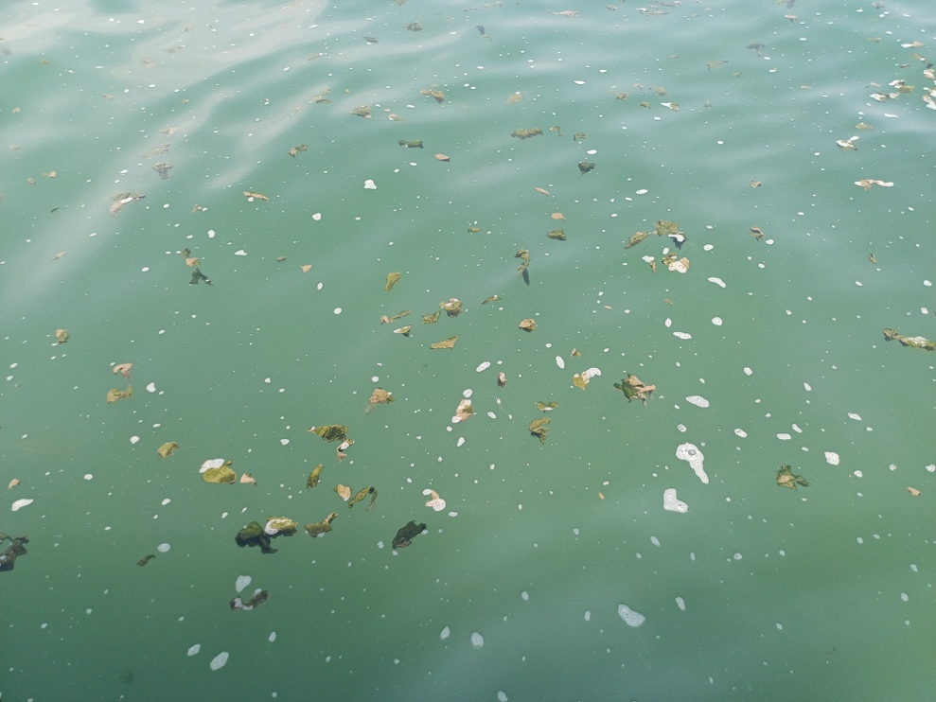
Plate 4. Floating aggregates of Koinonema sp. that rose from bottom mats. Photo by Oz Tzabari-Dar.

Ecology: Individual (microscopic) filaments of Koinonema sp. (Plate 1) attach onto new substrates and begin growing, accruing biomass and developing into macroscopic mats that cover extensive areas (Plates 2, 3). Later, air bubbles resulting from extensive photosynthesis cause peeling off and detachment of clumps from the mat, those float and aggregate at the surface (Plate 4), then die off, or settle on a new substrate to start a new accrual cycle - as detailed by Wood et al. 2015.

Physiological features: The species was isolated into lab cultures and several strains of it are maintained at the Israel National Culture Collection of Algae (Koinonema sp. strains C2024, C2035, C2041; INCCA - Israel National Culture Collection of Algae). Trichomes grown in liquid medium glide on the sides of the growth flask to form circular formations, confirming the gliding ability of this cyanobacterium. Molecular analyses confirmed that the isolates lacked genes for the biosynthesis of the cyanotoxins microcystins, cylindrospermopsins and anatoxin A. Further confirmation to the lack of toxicity was that the toxins were not found in water samples containing Koinonema sp. mats.

Cite this record as:
Ruth Kaplan-Levy, Emily Ben-Or, Alla Alster, Tamar Zohary. [Date when Item was last updated]. Electronic publication. Israel Oceanographic & Limnological Research. [Date when last accessed].
Further reading:
Buch B, Martins MD, Branco LHZ. 2017. A widespread cyanobacterium supported by polyphasic approach: proposition of Koinonema pervagatum gen. & sp. nov. (Oscillatoriales). Journal of Phycology 53(5): 1097-1105.
Wood S, Hawes I, McBride G, Truman P, Dietrich D. 2015. Advice to inform the development of a benthic cyanobacteria attribute. Cawthron Report no. 2752.

